1. We use the Java Editor NetBeans IDE 6.8 to build this sample.
1.1 You can download this software from the link http://netbeans.org/
1.2 Please install the JDK first before you install this software.
http://java.sun.com/javase/downloads/index.jsp
2. “JNA.jar” is a necessary library to call a DLL in JAVA.
2.1 Download JNA.jar here https://jna.dev.java.net/
2.2 Here is the JNA API documentation https://jna.dev.java.net/nonav/javadoc/index.html
3. Add “JNA.jar” into the JAVA project.
3.1 Open a new project.
3.2 Add JNA.jar by the following procedure.
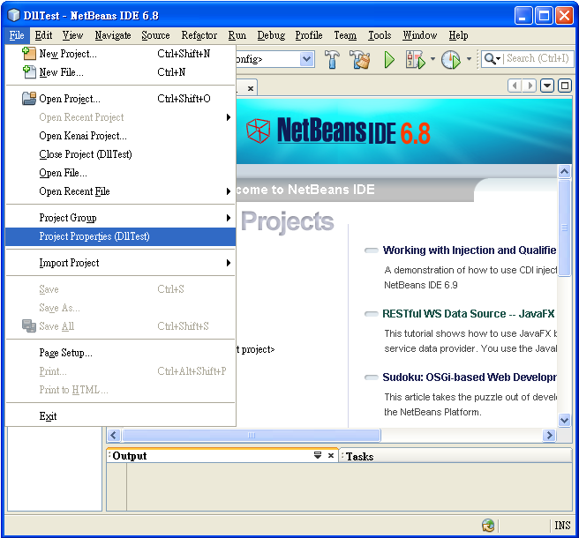

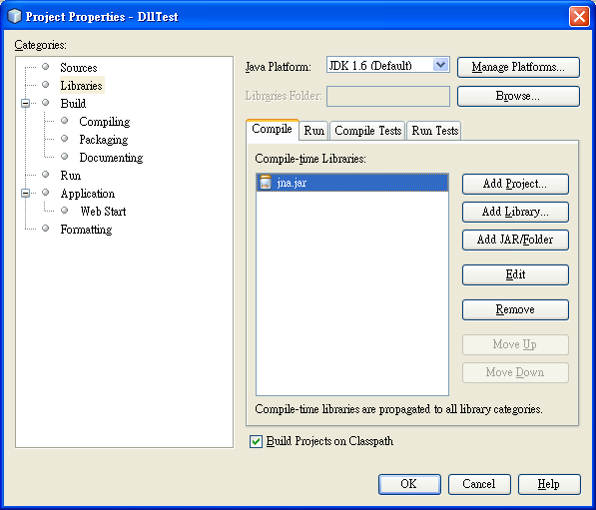
4. Copy the “TscLib.Dll” to the folder \\WINDOWS\system32.
5. Write and run your own program.
